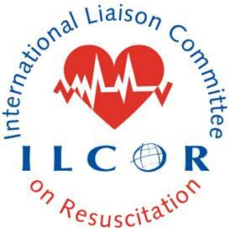This document summarizes the publication outputs that ILCOR sanctions related to the continuous evidence evaluation process:
- The systematic review including PROSPERO registration
- The Scoping review
- The COSTR posted on ILCOR.org
- The COSTR annual summary – all posted COSTR on ILCOR.org summarized with additional details and published in both Circulation and Resuscitation.
PICOST writing team completes systematic or scoping review and develops manuscript for publication in journal of their choice.

Lead author for systematic review drafts Consensus on Science (not Treatment Recommendations) and gives to lead and nodal (if applicable) TF chair(s) and inputs GRADE Evidence Profile Tables into online software. The TF chair generates the ETD framework from this software interface.
Annually, ILCOR scientific editors and TF chairs develop a CoSTR summary manuscript for a combined journal publication in Circulation and Resuscitation. This document will highlight all final ILCOR web postings and links to publications. The document will contain:
- Final Consensus on Science and Treatment Recommendations (identical to the final version posted on ILCOR Website).
- Task Force insights, Knowledge gaps
This document will not contain
- Grade tables, Forest plots, or E to D tables if they are already published or undergoing peer review or submission for peer review is planned.
The COSTR summary manuscript citation will be added to ILCOR.org posting of contributing COSTR(s)
Lead and nodal TASK FORCES discuss and debate the evidence and develop draft Consensus on Science with Treatment Recommendations (CoSTR) for posting on www.ilcor.org. Initial posting for public comment then final posting will be labeled DRAFT (compliant with circulation policy), containing:
- TF approved COSTR
For systematic reviews:
- Link to published systematic review and PROSPERO registration
- Evidence to Decision (E to D) framework tables
For scoping reviews:
- Link to published scoping review

Continuously, Writing Groups of Resuscitation Councils develop Council-Specific Guideline Updates and any necessary training materials consistent with ILCOR Web posting and their local process for updating Guidelines

