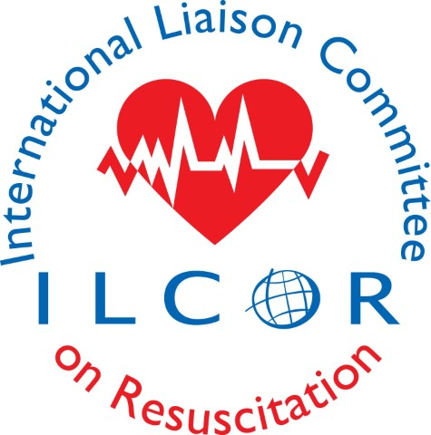
International Liaison Committee on Resuscitation (ILCOR) Systematic Reviews for First Aid and Resuscitation – Mentee Application

ILCOR is offering this systematic review mentorship opportunity to build capacity for the conduct of high quality systematic reviews (SR) in resuscitation. Selected applicants will volunteer to be a mentee on an ILCOR approved systematic review conducted and led by a contract expert in systematic reviews (ESR). The SR mentee will work collaboratively with the ESR to complete the work within the delegated timeline.

Each applicant completes the following and submits this to veronica.zamora@heart.org for review by the ILCOR Science Advisory Committee or delegate.

Section A: Why pursue this mentorship?

Please speak to your interest in ILCOR and/or systematic reviews and/or academic mentorship and/or your academic vision for what you would like to accomplish. Please include any areas of systematic review methodology that you wish to enhance through mentorship.

This section is limited to a maximum of 500 words, 11pt font minimum.

Section B: Individual Training and Relevant Publications
Provide a clear and concise description of your accomplishments highlighting the expertise and skills you have acquired related to:
- clinical epidemiology
- biostatistics
- resuscitation or first aid or critical care or emergency medicine or emergency medical services or education or paediatrics or neonatology;
- systematic review methodologies (range of methods including qualitative, quantitative, economic analyses);
- specific topic expertise

Please outline your training acquired to date related to research methodologies and systematic reviews if applicable.

This section is limited to a maximum of 1000 words, 11pt font minimum.

Section B: Infrastructure to Support the Work of the Systematic Review Expert

Please confirm access to pdf publications for most journals where the majority of resuscitation studies are published, through an academic institute or other access at no cost to ILCOR.
Yes_ No_

Section C: Relevant Experience
Provide a publication track record in systematic reviews if applicable (not a requirement).

Provide a publication track record in any other publication relevant to resuscitation that is not a systematic review.

Section D - References (3 required)

Company Name
Address
Contact Name
Contact Title
Contact Telephone Number
Contact email address
Date Work Undertaken
Nature of assignment
Confirmation Date*
* date that they were contacted and agreed to listing as a reference and willingness to be contacted.

Company Name
Address
Contact Name
Contact Title
Contact Telephone Number
Contact email address
Date Work Undertaken
Nature of assignment
Confirmation Date*
* date that they were contacted and agreed to listing as a reference and willingness to be contacted.

Company Name
Address
Contact Name
Contact Title
Contact Telephone Number
Contact email address
Date Work Undertaken
Nature of assignment
Confirmation Date*
* date that they were contacted and agreed to listing as a reference and willingness to be contacted.

