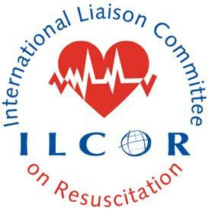 This document provides a checklist to guide Scientific Advisory Committee (SAC) members in their Evidence Update drafts or review of what is proposed to be posted on ILCOR.org. The SAC representative on the TF may or may not meet authorship criteria. The SAC rep will complete this checklist prior to submitting the Evidence Update and the checklist to the SAC chair. The SAC chair or delegate may assign the Evidence Update to a SAC member who is not involved in the writing group or taskforce(s) to independently review the Evidence Update. This process provides independent peer review prior to upload to ILCOR.org and formative peer feedback to members of SAC. The SAC chair or delegate will post the Evidence Update on ILCOR.org

ILCOR Evidence Update Review Content Checklist

Evidence update Title/AHA number:
Lead Author:
Date evidence update received:
Date SAC member completed checklist review:
SAC member:
SAC member recommendation that independent SAC peer review would be helpful:

This evidence update should comply with the current version of the evidence update worksheet, the approved PICOST and the authorship guidelines and the publication process and output (ilcor.org)

☐ Compliant with the approved PICOST
  - ☐ New PICOST or
  - ☐ revisited original PICOST: year of last review (SR and CoSTR, ScR or EU): _______
☐ Search strategy is appropriately rigorous (preferably done by IS and peer reviewed)
☐ Inclusion of updated search results (table and/or narrative summary)
☐ Date search last updated is within 6 months at time of review
☐ Task Force members who have contributed are included as collaborators
☐ Acknowledgment of contribution of information specialist
☐ Reviewer notes: (including whether this PICOST should have a systematic or scoping review)

