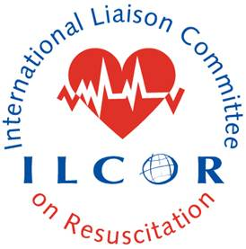This document provides the instructions on how to access worksheets used to justify the consensus on science and treatment recommendations published in 2010 and 2015.

**Effective February 9 2021**

**Access to the 2010 Digital Worksheets**

1. Reference the [C2010 Final Master Worksheet](https://heart-my.sharepoint.com/personal/veronica_zamora_heart_org/_layouts/15/guestaccess.aspx?docid=072cd6439bcc54b0fa14b314092a9b38c&authkey=AXFCP9f7Nf8dRcQpS-K9SWY&e=YxiWUC) to find a list of 2010 worksheets and their associated ID number.
2. Once you have found the worksheet title and associated ID number you may access the files by searching [here](https://heart-my.sharepoint.com/personal/veronica_zamora_heart_org/_layouts/15/guestaccess.aspx?folderid=026e5ce8a1a7041b7aa3e46f19c308b86&authkey=AejFEMHe2QcSS8yB5DuzC2c&e=2MLF76).

**Access to the 2015 Digital Worksheets**

1. Go to <https://volunteer.heart.org/apps/pico/Pages/default.aspx>
2. You must sign in or create a new account in order to access the worksheets. The sign in link is located at the upper right-hand corner of the page.
3. Once signed in, scroll towards middle of page to the ILCOR Reviews section:
4. Click on the link for the digital worksheet of interest. The worksheets are categorized by task force.

|  |  |
| --- | --- |
| [cid:image003.jpg@01D6FE39.4FA5B860](https://www.heart.org/heartorg) | **Veronica Zamora**  ILCOR Operations Manager  7272 Greenville Ave. | Dallas | TX | 75231  214.706.1487  [Veronica.zamora@heart.org](mailto:Veronica.zamora@heart.org) |

**CONFIDENTIALITY NOTICE:** This communication may include confidential information and is intended only for the use of the addressee(s). If you are not the intended recipient, please notify the sender immediately and do not disclose, store or copy the email or any related attachments.