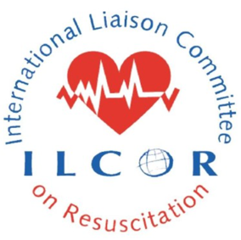
ILCOR SCIENTIFIC ADVISORY STATEMENT PROPOSAL

1. Proposed Manuscript Title

An Utstein Style Reporting Template for Cardiac Arrest Resuscitation Education Research

2. Environmental Scan

- What other papers are already available on same/ similar topic area

Currently there is no published literature that addresses this important topic specifically.

There are at least two related papers on Resuscitation Education that are relevant but neither focuses on reporting guidelines. The first is an ILCOR Advisory Statement from a Summit in 2001 and published in Circulation in Nov 2003 by Chamberlain and Hazinski, and the second is an American Heart Association Resuscitation Education Summit that was led by Cheng and Bhanji which was published in August 2018. Both of these papers focused on the quality of resuscitation education but neither focused on reporting guidelines that will be important to move the field forward.

- Previous systematic reviews:

Not applicable except to mention that the systematic review process for the Education, Implementation and Teams taskforce at ILCOR is negatively affected by the lack of reporting guidelines

- What ILCOR and member council guidelines will be cross-referenced?

The proposed paper will not cross reference current guidelines except to highlight gaps in the body of literature for resuscitation education

3. Need for the Paper - Please provide a subject summary. How will the paper support ILCOR’s mission, vision and values?

Educational efficiency represents a key component of the Utstein formula for survival from cardiac arrest yet none of ILCOR’s previous Scientific Statements have focused on this important component and little guidance has been provided to educational researchers in the domain.
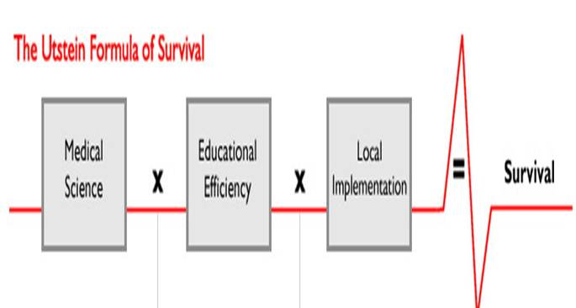

Educational science should guide the optimal instructional design and delivery of resuscitation courses, as well as other educational materials (such as CPR awareness campaigns, social media strategies, etc), which can subsequently lead to improved (clinical) performance and cardiac arrest outcomes. Unfortunately, the quality of published literature in resuscitation education remains poor, based on multiple ILCOR Evidence reviews and Consensus on Science statements. One major deficiency is the nature of reporting: (1) many studies fall short in reporting key elements of instructional design, making it hard to understand what components contributed to improvement in performance; and (2) outcomes are heterogeneous across studies, making it extremely difficult to conduct meaningful meta-analysis of educational studies. A standardized reporting guideline template could greatly support the development of higher quality educational research by providing guidance on what variables and outcomes to report.

ILCOR’s vision is: Saving more lives globally through resuscitation and its mission includes the rigorous review of the scientific literature (including that of education). Development of education reporting guidelines will help improve the quality of published educational research thereby supporting better educational practice, translating into better clinical performance and more lives saved.

4. Audience - Intended audience (e.g.: healthcare professionals, lay, policy makers, outside societies)

The intended audience for this paper are resuscitation education researchers and end users of that literature including journals, ILCOR’s Education, Implementation and Teams taskforce, Resuscitation Councils (particularly related to their own Guideline development), and front-line educators.

5. Lay Summary - Write a lay summary of 200 words or less (include clinical relevance)

Outcomes from cardiac arrest are influenced by science (or what we know about cardiac arrest and how to treat it), how well we train the lay public and health care providers (so they know what to do when it is needed), and how we implement ‘what we know’ into practice so that it can help cardiac arrest victims. Much of our focus to date has been on the science without understanding the best methods to educate. The published literature in resuscitation education is quite poor (as shown in the ILCOR reviews) and could be substantially improved with some guidance. Reporting guidelines can provide a framework upon which to judge educational research and inclusion into the ILCOR review process thereby helping improve the evidence review. It can also signal to potential researchers how to conduct their work as journals as well as ILCOR will be less willing to accept less relevant research. The long-term benefit will be better quality educational research which can then be implemented into training practices and ultimately help save more lives.

6. Implications – Will there be implications in this guideline/statement for public health and/or are there recommendations that will change the practice of clinicians? If so, please summarize.

Better educational research should result in changes to resuscitation courses (as well as other educational activities) which will affect front line teachers and learners.

7. Proposed Writing Group – 8-10 members in total. Provide full name, institution, and email address for each proposed member. Please consider ILCOR’s values of collaboration and diversity when making nominations.

Writing Group Chair Farhan Bhanji (HSFC)

Writing Group Vice Chair Adam Cheng (AHA / HSFC)

Writing Group Members Robert Greif (ERC), Gavin Perkins (ERC), Matthew Ma (RCA), Beth Mancini (AHA), Andrew Lockey (ERC), Judith Finn (ANZCOR), Jack Billi (AHA)

*Early Career Member Catherine Patocka (HSFC)

Minority Member Adam Cheng, Matthew Ma, and Farhan Bhanji

**All ILCOR member councils will be invited to nominate a writing group member if proposal is accepted**

8. Timetable for Completion of Paper – 6-9 months to time of peer review

Months 0-1: Finalize writing group members. Determine group consensus building process with writing group (most appropriate to complete at this stage, rather than prior to submission of the proposal, to respect International Committee of Medical Journal Editors (ICMJE) criteria for authorship)
Months 1-3: Literature review for outcomes used by researchers in resuscitation education. Monthly teleconferences, and off-line discussion, to determine the starting pool of variables to potentially include in the Utstein style reporting guidelines.
Months 3-6: Group consensus process (Delphi, standard survey and/or (virtual) consensus meeting process) to determine what is recommended for the final Utstein style template. Survey key stakeholders, including ILCOR EIT taskforce and ILCOR Member Councils, regarding inclusion elements (core, supplemental, exclude)
Months 6-9: Draft and revise manuscript for publication

