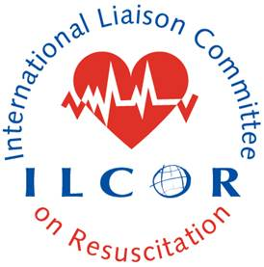This document provides a checklist to guide continuous evidence evaluation members in their review COSTR posting drafts. Usually two members of the continuous evidence evaluation team complete this for each submission to ILCOR. We aim to avoid using the CEE rep on the source Taskforce for the documents.
ILCOR CoSTR Content Checklist

CoSTR Title:
Date of CEE WG member Checklist Review:
Verified by CEE WG member:
Each item should comply with the current version of the CoSTR instructions document on ILCOR.org

Disclaimer for why CoSTR is marked ‘DRAFT’

CoSTR Citation

Methodological introduction)

Citation for systematic review and link to Pubmed (when available)

Inclusion of PICOST – comply with the version approved by CEE

Inclusion of PROSPERO registration number

Consensus on science

Treatment recommendations

Justification and technical remarks – narrative reporting of EtD Framework incorporating values and preferences

Knowledge gaps (ensure format is correct)

References listed alphabetically as per format

List of authors / collaborators approved by TF chair following CEE publication process and output document

Collaborator emails of approval included with submission, verifying compliance with publication policy

All relevant Evidence to Decision Tables are included

Reviewer notes:

