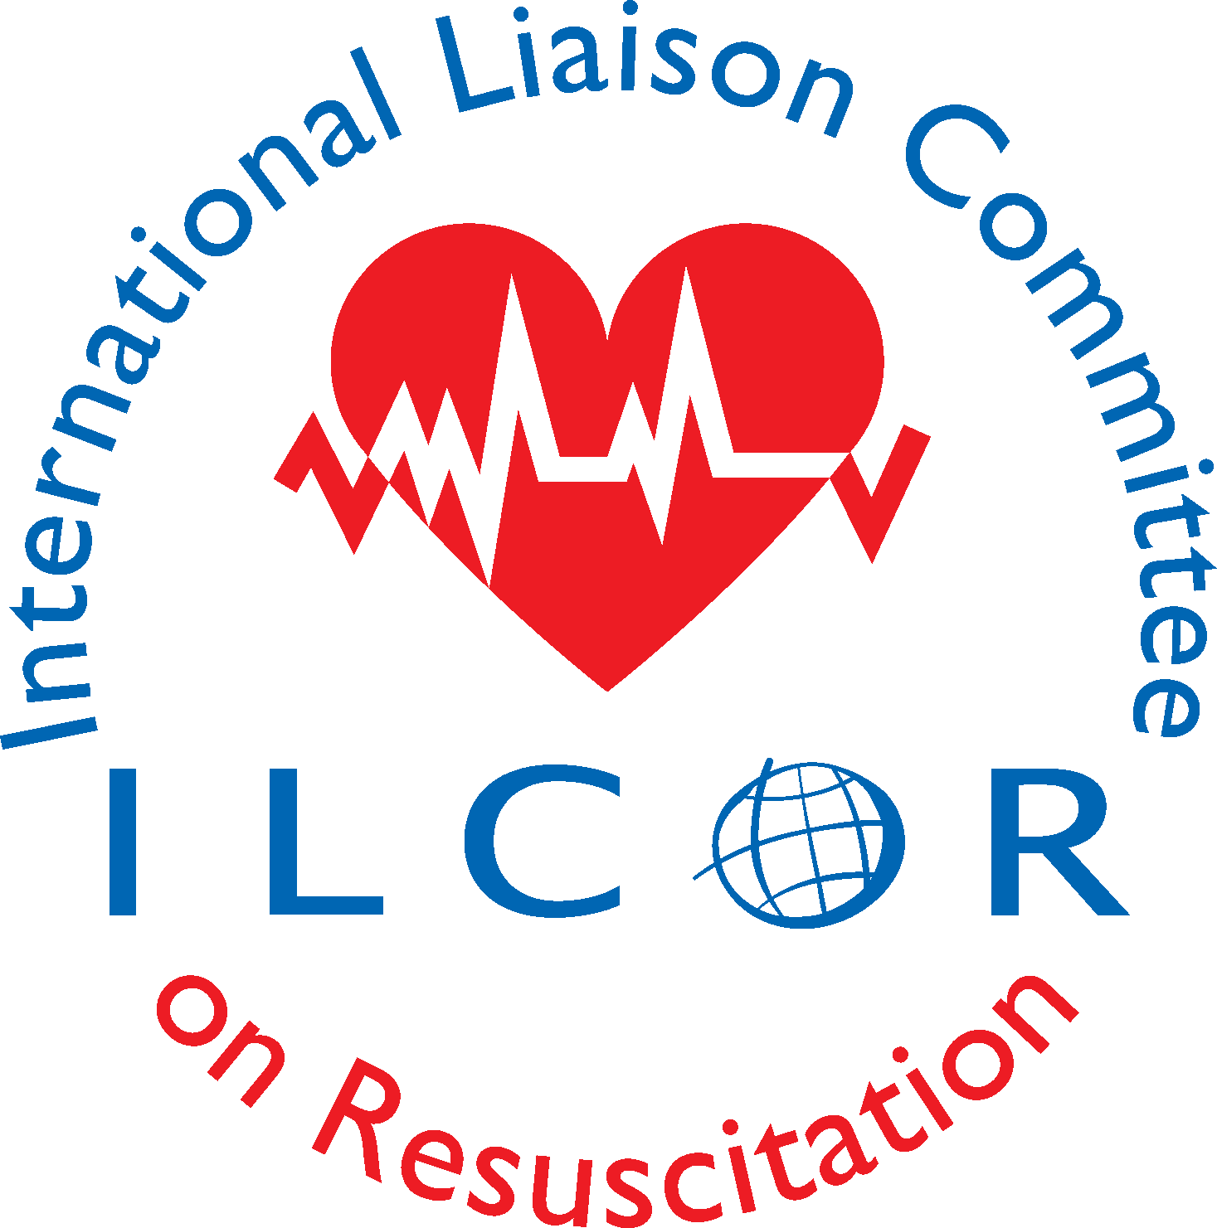
ILCOR Capetown Meeting Agenda
November 2-4, 2019
Marriott Crystal Palace Hotel Capetown South Africa
Host Council: Resuscitation Council of Southern Africa

Robert Neumar & Gavin Perkins, Co-Chairs ILCOR
David Stanton, Chair RCSA

SATURDAY 2 NOVEMBER
0730-1300 | Registration | RCSA | Foyer Crystal 1, 2
0800-0900 | SAC meeting | Peter Morley | Boardroom 6
0800-0900 | Research & Registries Working Group Meeting | Jerry Nolan | Boardroom 4
0900-1030 | Digital Communications Working Group Meeting | Koen Monsieurs | Boardroom 1
0900-1000 | ILCOR Board meeting | Robert Neumar Gavin Perkins | Boardroom 8
1000-1200 | Board, TFC/VCs, DL, SAC meeting | Gavin Perkins  Robert Neumar  Peter Morley  Maaret Castren | Crystal 1&2
1100-1200 | Membership Working Group Meeting | Vinay Nadkarni | Boardroom 2
1200-1300 | LUNCH for all  1230-1300-Opening Welcome, Announcements, Conflict of Interests, Charge for this meeting, C2020 information | Gavin Perkins Robert Neumar | Crystal 1,2
1300-1400 | SAC update –  - TF led reviews  - KSU/ESR reviews  - Prognostic and Diagnostic Templates | Peter Morley | Plenary
1400-1600 | Task Force Breakout Session  PICOSTs, CoSTRs, ESR/KSU SRs, TFSRs and TF Scoping Reviews -Discussion and Decisions | Each Task Force hears presentations and discussions. 14 one-hour sessions/PICOx6TF=84 PICOs discussed and progressed to meet deadline of 2 January2020 | TF Breakout Rooms  (see room assignments below)
1600 | ~TEA BREAK~
1630-2100 | Task Forces to meet in breakout rooms.  PICOSTs, CoSTRs, ESR/KSU SRs, TFSRs and TF Scoping Reviews-Discussion and Decisions  To include  WORKING DINNER~possible plenary session on social media | NLS  FA  BLS  EIT  PLS  ALS | TF Breakout Rooms  (pending)_  Crystal 4  Boardroom 2  Boardroom 6  Board room 7  Boardroom 1  Crystal 3
SUNDAY 3 NOVEMBER
0630-0700 | All participants have breakfast in your respective hotels as breakfast is included in the room rate
0700-0800 | Task Forces to meet in breakout rooms. |  | TF Breakout Rooms
0700-0800 | ILCOR Board, SAC, DLs and TFC/VC | Bob Neumar Gavin Perkins | Crystal 1,2
0800-0900 | Plenary presentations from task forces on work done yesterday |  | Crystal 1,2
0900-1200 | Task Force Breakout Session  PICOSTs, CoSTRs, SRs, ESR/KSU. TFSRs and TF Scoping Reviews -Discussion and Decisions | Tea Break 1000-1030 | TF Breakout Rooms
1200-1330 | LUNCH for all together-Introduction to algorithm review | Bob Neumar, Vinay Nadkarni, Ian Maconochie | Crystal 1,2
1330-1600 | Task Force Breakout Session  Algorithms (up to 2 hours) |  | TF Breakout Rooms
1600-1615 | ~TEA BREAK~
1615-1815 | Task Force Breakout Sessions  PICOSTs, CoSTRs, ESR/KSU SRs, TFSRs and TF Scoping Reviews -Discussion and Decisions |  | TF Breakout Rooms
1815 | ~GROUP PHOTO~
1830-2130 | ~OFF-SITE DINNER~  *Meet in lobby to board shuttle.  Two Oceans Capetown Aquarium  https://www.aquarium.co.za/
MONDAY NOVEMBER 4
0700 | Breakfast for all Colosseum and Marriot guests in the Marriott
0700-0830 | Breakfast and Algorithms discussions or Scientific Statement proposals | Gavin Perkins | Crystal 1,2
0830-1130 | Task Force Breakout Sessions | Tea Break 1000-1030 | TF Breakout Rooms
1130-1300 | Plenary TF Feedback  - Evidence evaluation next steps | Bob Neumar  Gavin Perkins  Peter Morley | Crystal 1,2
1300 | ~LUNCH FOR ALL & CLOSE OF MEETING~  *Meeting ends for all except delegates to business meeting. |  | Location TBD
1400-1700 | General Assembly Meeting  *Closed meeting for delegates and invited observers only. | Gavin Perkins, Robert Neumar, ILCOR Delegates and Official Observers | Crystal 1,2
1300-1700 | OPTIONAL TASK FORCE MEETINGS |  | TF Breakout Rooms
TUESDAY 5 NOVEMBER -0800-1000 ILCOR SESSION in Emergency Medicine Society of Southern Africa Conference (each TF presents 10 minute update on advances in the science)

