Access to the 2015 Digital Worksheets

Instructions to access the digital worksheets please follow these steps:

- Go to Ilcor.org/seers
- You must sign in or create a new account in order to access the worksheets. The sign in link is located at the upper right-hand corner of the page.
- Once signed in, scroll towards middle of page to the ILCOR Reviews section:
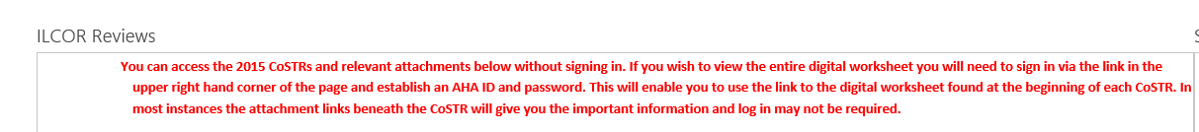

3. Click on the link for the digital worksheet of interest. The worksheets are categorized by task force.

