**CONFIDENTIAL DO NOT DISTRIBUTE**
Proposed Evidence Update Process Document for Remaining PICOTs
not covered by ILCOR systematic or scoping reviews

ILCOR PICO review process
  - ILCOR CEE Systematic Review
  - ILCOR Task Force Systematic Review
  - ILCOR Task Force Scoping Review
  - ILCOR Evidence Update

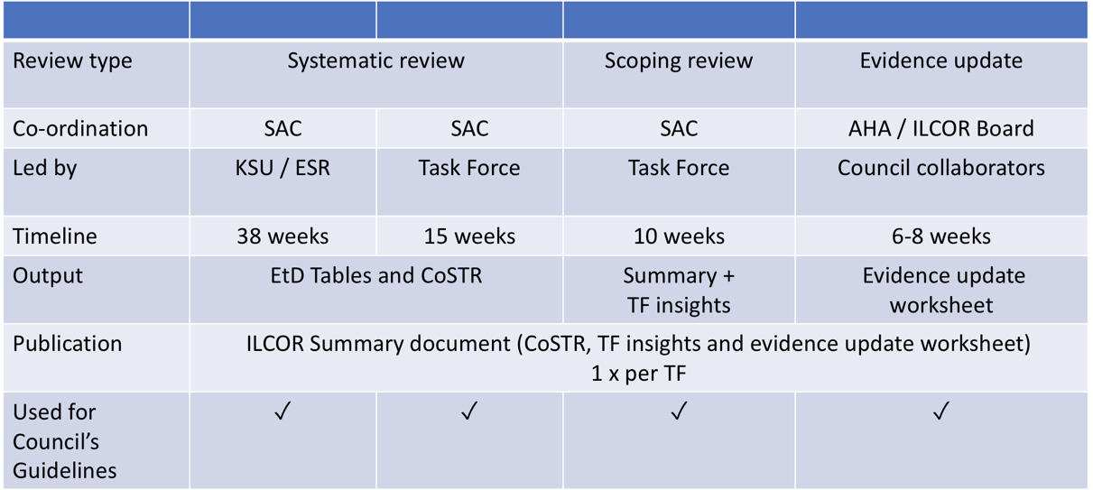

Evidence Update Process for topics not covered by ILCOR Task Forces systematic or scoping reviews
      - ILCOR has prioritised PICO questions based on importance and presence of new data for systematic or scoping reviews.
      - This evidence update process is only applicable to PICOSTs which are not being reviewed by ILCOR as systematic or scoping reviews.
      - Remaining PICO Questions:
  - 2015 Recommendations were derived from PICO Questions
    - PICOs are numbered and match to at least one if not more recommendations
  - 2010 PICOS were not numbered and therefore matching may be more
challenging. Worksheets are available online.
  - URL for 2010 Worksheets: https://heart-my.sharepoint.com/personal/veronica_zamora_heart_org/_layouts/15/onedrive.aspx?id=%2Fpersonal%2Fveronica%5Fzamora%5Fheart%5Forg%2FDocuments%2FCoSTR%20Worksheets
  - URL for 2015 Worksheets: https://volunteer.heart.org/apps/pico/Pages/default.aspx
**AHA login required to view digital 2015 worksheet**

Simplified process for evidence update
- Copy and paste the most recent Consensus on Science and Treatment Recommendation from the 2010 or 2015 ILCOR summary document into the evidence update worksheet
- Single reviewer re-runs search strategy where available or use general search strategy outlined below
- Run search strategies on EXISTING PICO
- 2015: limit search to 1/1/2013 to current for observational studies and RCTs only (do not include case studies) using PUBMED
- 2010: limit search to 1/1/2008 to current for observational studies and RCTs only (do not include case studies) using PUBMED
- Identify relevant studies: systematic reviews, guidelines, randomized controlled trials (RCTs) and non-randomized studies (non-randomized controlled trials, interrupted time series, controlled before-and-after studies, cohort studies, large case series n>20) that concern directly the population and intervention described
- Review reference lists of identified articles for any other eligible articles
- Summarise key information from relevant articles on study summary table for RCT or Non-RCT studies.
- Provide an opinion on whether any of the new studies identified contain information which may require a review/update of previous Treatment Recommendation
- Submit to Evidence Update Co-ordinator (Dr. Peter Morley) and Veronica Zamora (AHA)
- Once approved, SAC Chair notifies ILCOR Board who will acknowledge receipt.
- Evidence update must be completed within 8 weeks of start

PUBMED (using advanced search with the operators: AND, OR, NOT)
- Your specific topic words: “xx” [MESH] OR “xxx” [TIAB]
- Population:
  - If CA: “life support care” [MESH] OR “life support” [TIAB] OR cardiopulmonary resuscitation [MESH] OR “cardiopulmonary resuscitation” [TIAB] OR ROSC [TIAB] OR “return of spontaneous circulation” [TIAB] OR heart arrest [MESH] OR “cardiac arrest [TIAB]
  - If no CA: NOT (heart arrest [MESH] OR “cardiac arrest [TIAB])
  - Critical illness terminology: "Critical Illness"[Mesh] OR "Critical Illness"[tiab] OR emergenc* [TIAB] OR emergencies [MESH] OR emergency medicine [MESH] OR acute disease [MESH]
- To exclude animal studies: NOT (animals [mh] NOT humans [mh])
- Optional: NOT “respiration, artificial”[MESH]
- Optional limiting to articles with children or adolescent data, broadest search:
infan* OR baby OR baby* OR babies OR toddler* OR minors OR minors* OR kid OR kids OR child OR child* OR children* OR schoolchild* OR schoolchild OR school child[tiab] OR school child*[tiab] OR adolescen* OR juvenil* OR youth* OR teen* OR under*age* OR pubescen* OR pediatrics[mh] OR pediatric* OR paediatric* OR peadiatric* OR school[tiab] OR school*[tiab]
  - Optional exclude neonatal papers by
NOT (newborn* OR new-born* OR perinat* OR neonat* OR prematur* OR preterm*)
The above is a predefined BMI block (reference due: https://blocks.bmi-online.nl)

- In view of limiting to guidelines and reviews (or excluding), can be further adapted as needed:
  - "Guidelines as Topic"[Mesh] OR "Guideline"[Publication Type] OR guideline*[tiab] OR recommendation*[tiab] OR cpg[tiab]
  - review[tiab] OR "Review"[Publication Type] OR "Meta-Analysis as Topic"[Mesh] OR meta-analysis[tiab] OR "Meta-Analysis "[Publication Type]
  - NOT "Letter"[Publication Type] OR "Editorial"[Publication Type] OR “Comment"[Publication Type])

Example of RCT:
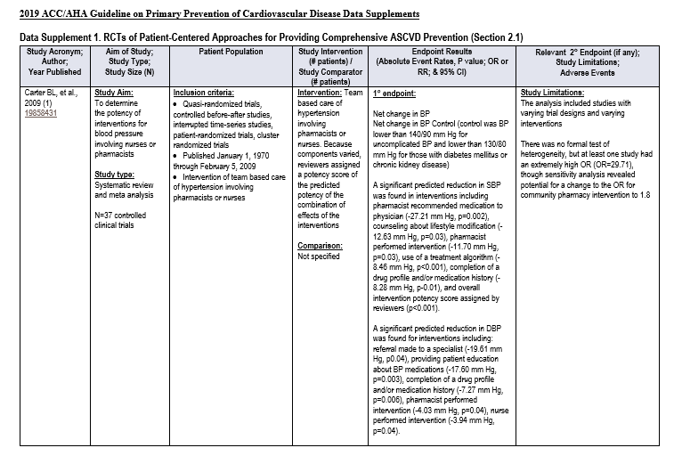
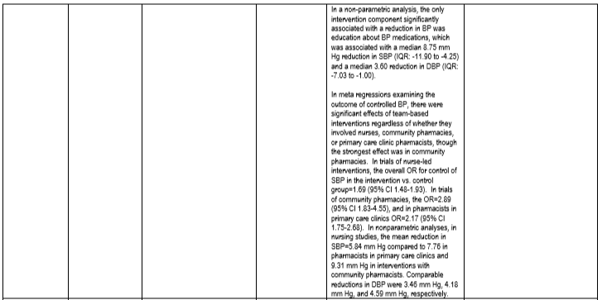

Example Non-RCT/Systematic Reviews
